- \Operation\Tube filling\Weight settings
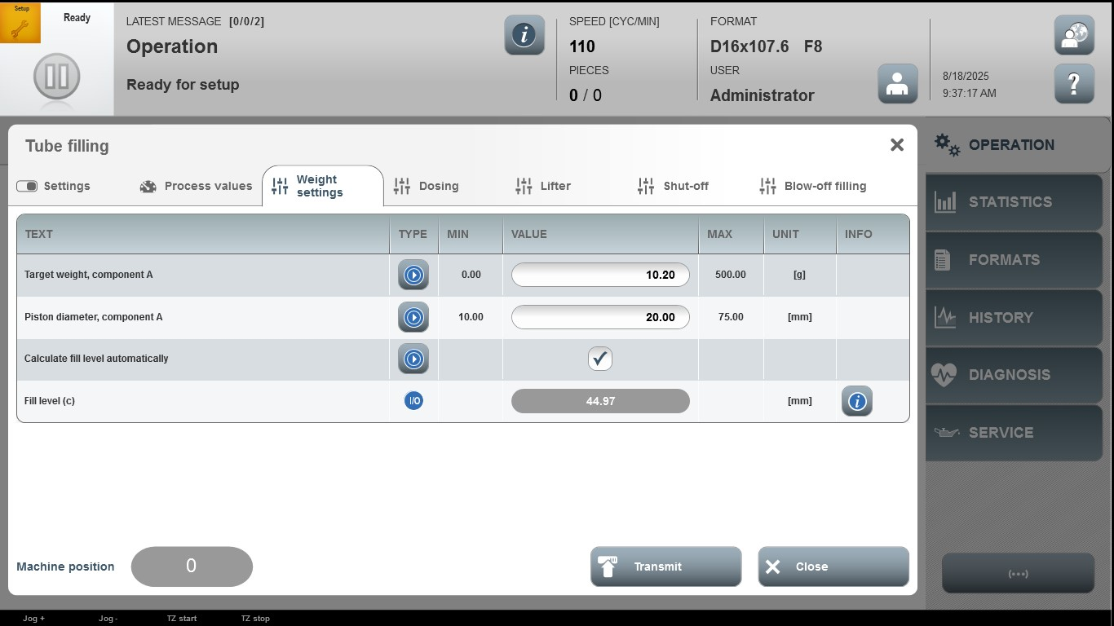

Acceptance criterion | Limits | Pass / Fail: Dev-No. | Date | Initials
Screen matches screenshot | N / A
Target weight, component A | 0.00…500.00
Piston diameter, component A | 10.00…75.00

